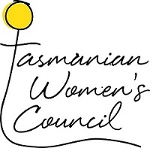

Tasmanian Women’s Council

Meeting Communiqué

13 February 2025

The Tasmanian Women’s Council acknowledges Tasmanian Aboriginal people as the Traditional Owners and custodians of the land on which the Council met.

The Council recently held a successful strategic planning day, facilitated by Maura Boland, Director of Insight Partnership. This session provided an opportunity to reflect on achievements to date, review the Council’s Terms of Reference, and plan for the future.

**Key updates from the meeting include:**

**Updated Terms of Reference:**

The Chair role has changed from an ex-officio position held by the Department of Premier and Cabinet (DPAC) Deputy Secretary to a member-elected Chair.

It was discussed that membership will grow from eight to ten members to broaden expertise and perspectives.

Meetings will now be held more frequently to support stronger engagement and timely action.

**Future Meetings:**

Forward annual meetings will be held in June, September and December each year.

**Forward Work Plan and Priorities:**

Council Members agreed to theme each meeting around a specific priority area.

The 2025 priority areas are:

• Housing

• Sports

• Health

• Education

The next meeting of the Council will take place on **Thursday 19 June 2025**, with Housing and Homelessness as the primary focus.

The Council looks forward to continuing its collaborative work with government, community, and stakeholders to advance outcomes for Tasmanian women.